Technical Assistance from Gansu Agricultural University to National Potato Research Program for High Quality and High Efficiency Seed Potato Propagation and Breeding
A memorandum of understanding (MOU) was signed between Nepal Agricultural Research Council (NARC) and Gansu Agricultural University (GAU), Lanzhou, Gansu Province, People's Republic of China in December 2020. A project " High Quality and High Efficiency Seed Potato Propagation and Breeding for Nepal" funded by the Ministry of Science and Technology of the People's Republic of China under technology assistance program, was approved for implementation as per the MOU between the College of Life Science and Technology, GAU and National Potato Research Program (NPRP), NARC. Recently, laboratory equipment (Table 1) donated by College of Life Science and Technology, GAU arrived in NPRP for upgrading the tissue culture laboratory. These equipment are functioning efficiently at NPRP.
Table 1 Laboratory equipment donated by College of Life Science and Technology, GAU, China to NPRP, NARC, Nepal
SN | Name of items | Model | Brand | Unit | Unit-price (RMB) | Price (RMB)
1 | Clean bench | SW-CJ-2FD | Made in China | 3 | 12000.00 | 36000.00
2 | Manual pipette | Research plus | Made in China (Eppendorf) | 15 | 1800.00 | 27000.00
3 | Vertical steam sterilizer | DGL-100B | Made in China | 2 | 12000.00 | 24000.00
4 | LED type overhead light incubator | GDN-1000D-4 | Made in China | 2 | 15000.00 | 30000.00
5 | Experimental pH meter | PHSJ-6L | Made in China | 2 | 10000.00 | 20000.00
6 | Full Wavelength Micro-plate Analyzer | HBS-ScanX | Made in China (DeTie) | 1 | 55000.00 | 55000.00
7 | High-speed refrigerated centrifuge | TGL-1650 | Made in China | 1 | 35000.00 | 35000.00
8 | Electronic balance | PX224ZH | Made in China (OHAUS) | 2 | 10800.00 | 21600.00
Total |  |  |  |  |  | 248600.00

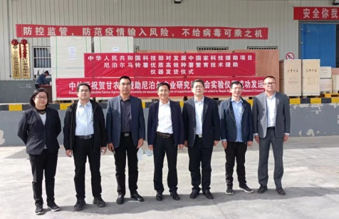 | 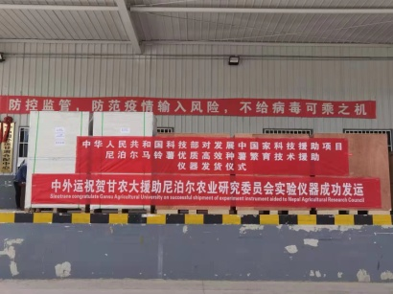 | 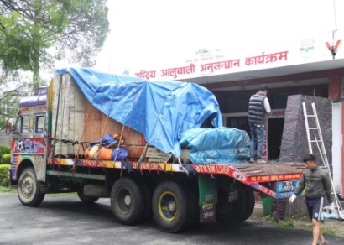
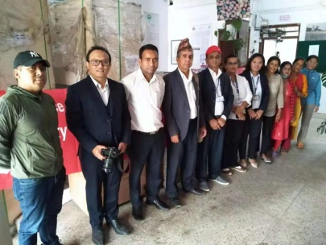 | 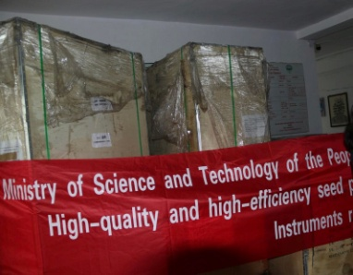 | 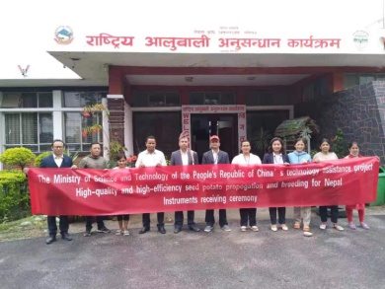

A two-day virtual training was conducted as a part of "High Quality and High Efficiency Seed Potato Propagation and Breeding for Nepal'' project on 8th and 9th February, 2023. More than 25 participants directly involved in potato research, development and seed potato production participated in the virtual training from Nepal. The training program was commenced by Dr. Xun Tang by introducing Prof. Si Huaijun, Dean, College of Life Science and Technology, GAU, Principal Investigators of the project in China, and Dr. Giridhari Subedi, Coordinator, National Potato Research Program, NARC, Principal Investigator of the project in Nepal. Prof. Si Huaijun welcomed all the participants of training. Prof. Si was elated in sharing the online platform for potato tissue culture, microtuber production, seed potato production, and potato virus detection with the participants of Nepal. Dr. Giridhari Subedi was honored to The Ministry of Science and Technology, The People's Republic of China for funding the project "High Quality and High Efficiency Seed Potato Propagation and Breeding for Nepal". Dr. Subedi expressed his sincere gratitude for Prof. Si Huaijun, and Dr. Ramchandra Adhikari, Outgoing Director, Planning and Coordination, NARC for developing the project. Dr. Subedi thanked Dr. Xun Tang and Dr. Birendra Bahadur Rana for their continuous effort for momentum of the project. Dr. Subedi requested all the participants to actively participate in the online training and Q/A sessions.
 | 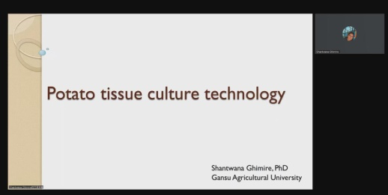 | 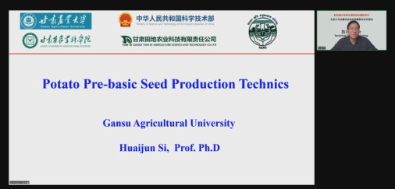
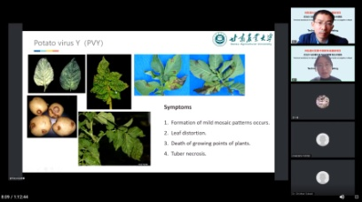 | 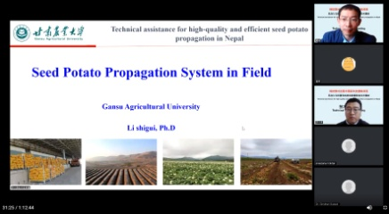 | 

Dr. Shantwana Ghimire, Postdoctoral Researcher, State Key Laboratory of Grassland Agro-Ecosystems, Lanzhou University delivered first lecture on tissue culture techniques. Dr. Shantwana explained in detail the types of equipment and chemicals required in the tissue culture laboratory, media preparation and growing conditions. The lecture of Dr. Shantwana was followed by the lecture of Prof. Si Huaijun. Prof. Si shared the moment of Nepal visit in his presentation. Prof. Si explained the way of microtuber production in glass houses through his well spoken pictorial slides. On the second day, Dr. Xin Jin, College of Life Science and Technology, GAU, delivered a lecture on potato viruses and detection techniques. Potato viruses are the primary biotic factors of seed quality deterioration and yield reduction. Potato viruses are very difficult to detect by visual observation. Dr. Xin clarified different serological and molecular techniques used for virus detection. The last lecture was delivered by Dr. Li Shiguai, from the College of Life Science and Technology, GAU on seed potato propagation systems in the field. He explained different techniques used from soil amendments, fertilizers, seed treatment including manual and machine planting. Dr. Xun Tang had facilitated the whole session. The training would be a milestone in upgrading the technical knowledge of related stakeholders.

